Buzzer Interfacing Using Esp32

Description:
The Buzzer Interfacing project using ESP32 demonstrates how to interface a buzzer with a Wi-Fi enabled microcontroller to produce sound alerts.
A buzzer is an audio output device that generates sound when an electrical signal is applied.
This project is commonly used in alarm systems, notification systems, and warning indicators.

Block Diagram:
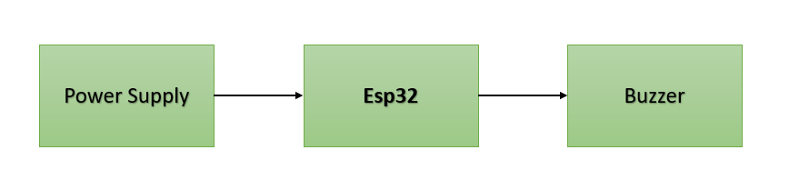

Pinout / Circuit Connection:
ESP32 GPIO 18 → Buzzer (+)
Buzzer (–) → GND
Power supply: 3.3V logic from ESP32 (powered via USB)

Components Required:
ESP32 Development Board
1 x Active Buzzer
Jumper wires
Breadboard
Working Principle:
The project works on the principle of digital GPIO control.
When the ESP32 sends a HIGH signal (3.3V) to the buzzer pin, current flows through the buzzer and it produces sound.
When the signal is LOW, the buzzer stops producing sound.

Operation (Step-by-Step):
- Connect the buzzer to the ESP32 as per the circuit connection.
- Connect the ESP32 to a computer using a USB cable.
- Select the correct ESP32 board and COM port in the Arduino IDE.
- Upload the buzzer interfacing program to the ESP32.
- Power ON the ESP32.
- The buzzer turns ON for a fixed duration.
- After the delay, the buzzer turns OFF automatically.
- This process repeats continuously.

Arduino Code:
int buzzerPin = 18;

void setup() {
pinMode(buzzerPin, OUTPUT);
}

void loop() {
digitalWrite(buzzerPin, HIGH); // Buzzer ON
delay(1000); // 1 second delay
digitalWrite(buzzerPin, LOW); // Buzzer OFF
delay(1000); } // 1 second delay
Conclusion: (Predefined/self-written)
The Buzzer Interfacing project using ESP32 helps students understand how ESP32 controls audio output devices using GPIO pins.
It is useful for learning alert and notification systems and serves as a foundation for IoT-based alarm applications.

For Your References:
[1] Espressif Systems, ESP32 GPIO Programming Guide.

